NAME : DANJUMA ALICE OMALI

MATRIC /NO: UJ/2024/NS/0208

INSTITUTION : UNIVERSITY OF JOS

DEPARTMENT : COMPUTER SCIENCE

PROJECT TITLE: NETWORK DISCOVERY AND TRAFFIC ANALYSES

INTRODUCTION
This project demonstrates network discovery on my workstation via HUAWEI hotspot.
Tasks: hostname, IP address, MAC address, gateway, DNS, ping, nslookup, traceroute, wireshark ICMP/DNS.
TABLE OF CONTENT:
- Network configuration
- Connectivity Testing
- DNS Lookup
- Routing
- Wireshark ICMP capture
- Wireshark DNS capture
- Security questions
- conclusion

TASK 1: WORKSTATION AND NETWORK INTERFACE
- Hostname-----DESKTOP-QCTU0J0
- Ipv4:192.168.43.1
- Mac:4a:47:98
- Gateway:192.168.43.1
- Network interface used: WI-FI(wireless LAN)

- W3_01_network_configure_evidence
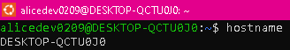
- W3_02_network_configure_evidence
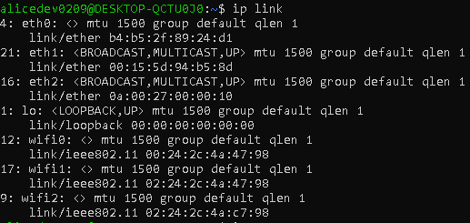

- W3_03_network_configure_evidence
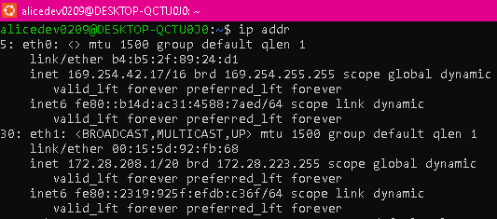
  - W3_04_network_configure_evidence
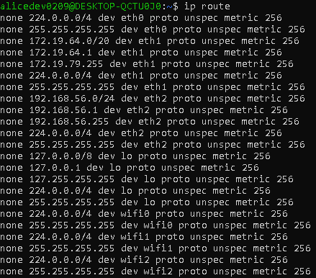

TASK 2: DNS INFORMATION
1. Hostname:DESKTOP-QCTU0J0
2. Ipv4:192.168.43.1
3. Mac address:4a:47:98
4. Default Gateway:192.168.43.1
5. Network interface:WI-FI
6. DNS server address--- 192.168.43.1
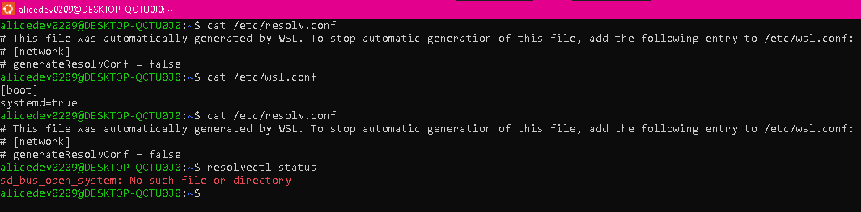
TASK 3:CONNECTIVITY
Three connectivity tests were carried out to verify different parts of the network path:
- ping 127.0.0.1 — SUCCESS. This confirmed that the local loopback interface and basic network stack were functioning.
- ping 192.168.43.1 — SUCCESS. This confirmed that the workstation could reach the local gateway over the Wi-Fi connection.
- ping 8.8.8.8 — SUCCESS. Four replies were received, confirming Internet reachability. The ICMP exchange was also observed in Wireshark.
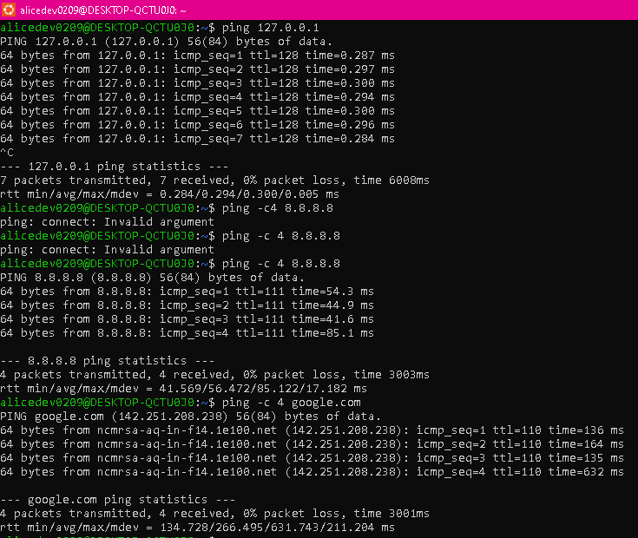

TASK 4: DNS LOOKUP
The command nslookup google.com was used to examine DNS resolution. The local DNS server identified during the exercise was 192.168.43.1. The query requested address information for google.com, including A and AAAA records. The captured DNS response contained an IP address for google.com, demonstrating that the DNS service translated the human-readable domain name into an IP address.

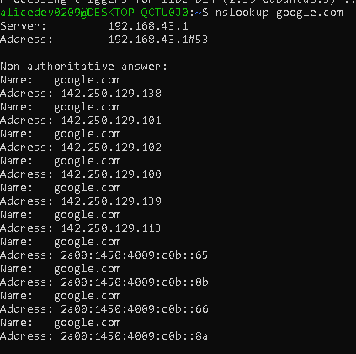

TASK 5: ROUTE INVESTIGATION
The command nslookup google.com was used to examine DNS resolution. The local DNS server identified during the exercise was 192.168.43.1. The query requested address information for google.com, including A and AAAA records. The captured DNS response contained an IP address for google.com, demonstrating that the DNS service translated the human-readable domain name into an IP address.
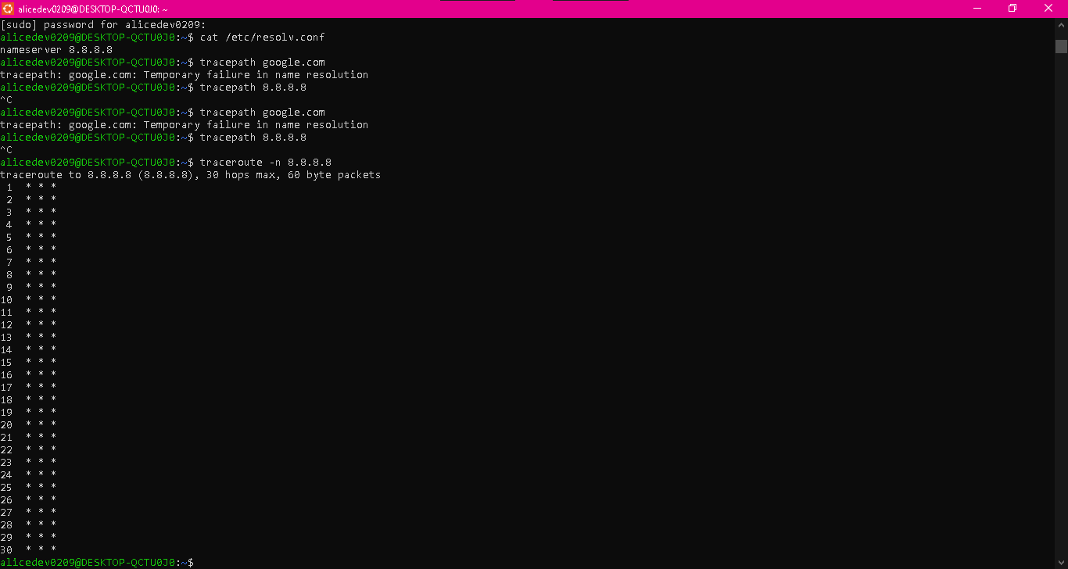

Number of visible hops: 30
What a hop represent: A router forwarding packets.

Task 6: WIRESHARK ICMP CAPTURE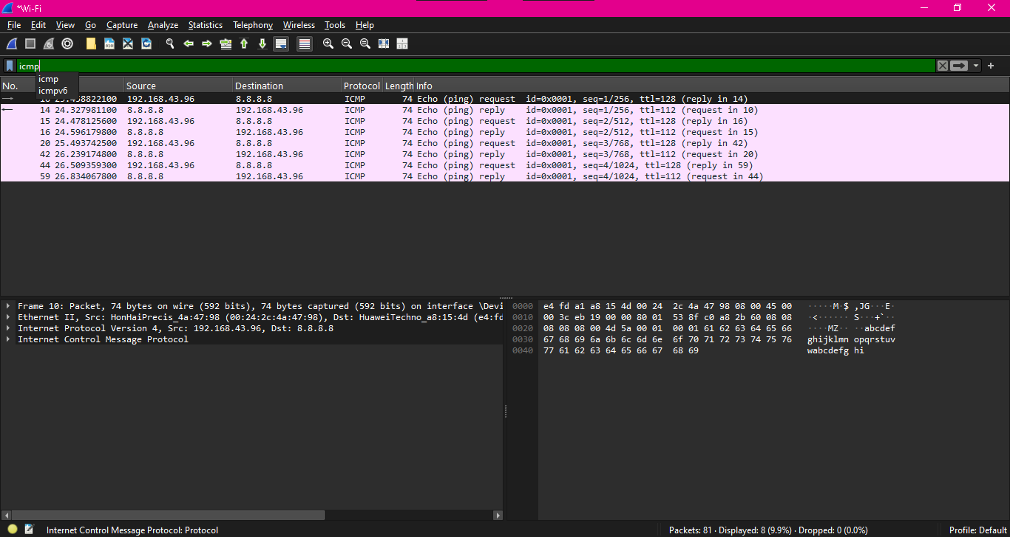

INFORMATION | ECHO REQUEST | ECHO REPLY
Packet number | 10 | 14
Source ip | 192.168.43.96 | 8.8.8.8
Destination ip | 8.8.8.8 | 192.168.43.96
Protocol | ICMP | ICMP
Type | Echo Request len 74 | Echo reply

Task 7:WIRESHARK DNS CAPTURE
INFORMATION | RESULT
Source ip | 192.168.43.1
Destination ip | 8.8.8.8
Requested domain | Google.com
Returned ip address | 192.168.43.96

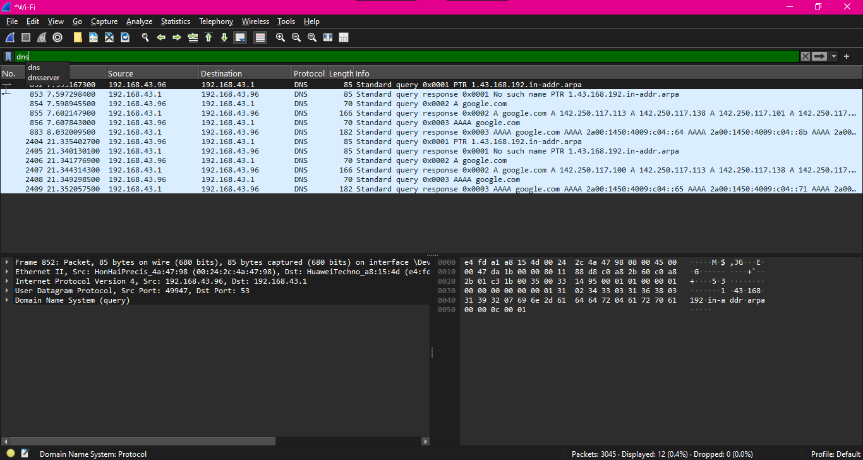

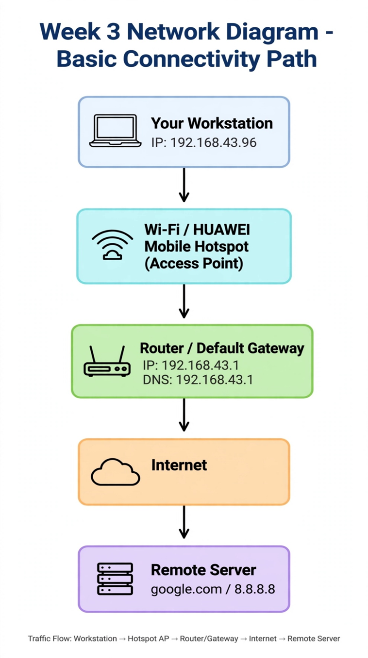
SECURITY OBSERVSTION QUESTIONS

1. Purpose of Ip address: Logical identifier to locate host and route packets.
2.IP VS MAC address
IP Address | MAC Address
Is use for global network communication | Is use to identify local network  Interface in a device
It’s dynamic | It’s permanent
It consist of numbers | Both numbers and letters

3. Purpose of Default gateway: Forwards packets from local LAN to External networks/internet.
4. What DNS does: Translates human names to ip addresses.
5. Failed ping misleading: Firewall may block ICMP but host up; congestion/limiting.
6. Wireshark ICMP: I saw Echo Request/Reply, ips,96 <> 8.8.8.8 protocol ICMP, Lengthn, time.
7. DNS Query/Response: Query a google.com .96->1, response .1->96 with IP, also PTR and AAAA
8. Why inspect network traffic: Detects threats, troubleshoot, verify security policies,learn protocols
9. Only authorized capture:Privacy,legal,ethics,cannot captureothers traffic without consent.
10. Most useful: understanding DNS as 192.168.43.1 and using display filters icmp/dns-makes invisible traffics visible.

Conclusion : This project provided hands on practical experience with basic network discovery and traffic analysis .

